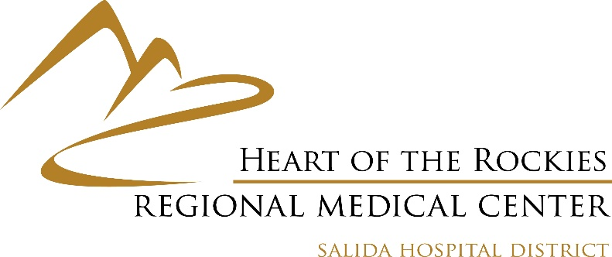

**Board Member Summary of Qualities and Characteristics**

HRRMC is a large and complex organization operating in a challenging healthcare environment. With margins being razor-thin, it is essential to carefully manage our financial situation to ensure the continued provision of services. Our goal is to offer as many services as possible to the Hospital District, allowing our community to receive needed medical care locally. However, this is always dependent on the financial feasibility, the needs of the community, the hospital’s ability to absorb new services, and the availability of qualified providers.

The Board plays a critical role in overseeing these efforts and must remain highly engaged. With five members, the Board is responsible not only for regular Board duties but also for active participation in committees.

In order to be successful in these critical oversight roles, Board members should possess the following qualities:

* Strong understanding of financial management in a healthcare setting
* Commitment to ensuring the long-term sustainability of HRRMC
* Ability to balance the needs of the community with available resources
* Collaborative approach to decision-making
* Willingness to serve on committees and contribute to the overall success of the organization
* Dedication and willingness to devote a considerable amount of time every month towards board initiatives.

**Eligibility to run**

To run for the Board of Directors, a candidate must be an eligible voter residing within the Health District boundaries.

Required forms

SELF-NOMINATION AND ACCEPTANCE FORM (due by February 28, 5 p.m.)

AFFIDAVIT OF INTENT TO BE A WRITE-IN CANDIDATE (due by March 3, 5 p.m.)

If there are more candidates than available seats, an election will be held on May 6, 2025. District residents will vote on May 6 in person or via absentee ballot.

For more information or if you have any questions, please contact Juanita Ward, Designated Election Official: [Juanita.ward@hrrmc.net](mailto:Juanita.ward@hrrmc.net)